**DUTY FREE WAREHOUSE – BACKEND**

**Deployment Instruction**

|  |  |
| --- | --- |
| **Project Name** | **DUTY FREE WAREHOUSE** |
| **Client Name** | **Duty Free Warehouse** |
| **Revision** | 1.0 |
| **Created Date** | 2020/09/25 11:50 AM |
| **Date Updated** | 2020/09/25 11:50 AM |
| **Document Name** | DUTY FREE WAREHOUSE – BACKEND – Deployment Instruction |
| **Target Audience** | System Users |

Contents

I. Hardware and Environment Requirement 3

II. Migrate Database 3

III. Download and Update Source Code 3

IV. Configure Setting and Database 3

V. Run and Kill The Dotnet Service 6

VI. Introduction to API Testing Suite 6

VII. Trobleshooting 6

# Hardware and Environment Requirement

* ***Environment***:
  + .Net Core Version 2.2
  + RDS: MariaDB or MySQL (advice)
* ***Requirements Minimum hardware configuration***:
  + CPU: 2 Core
  + RAM: 4 GB
  + HDD: 60 GB
  + OS: Ubuntu 16.x (x64 bit) or above
* ***Note***: Dedicated server or EC2 server

# Migrate Database

* ***Syntax***: mysql -u <username> -p <database_name> < <Path/<file_name>.sql>, download the file at: dutyfree_db.sql (Follow the path in Git: \Deployment\Data\MariaDB\[dutyfree_db.sql](https://drive.google.com))
* ***Example***: mysql -u root -p test_db < dutyfree_db

# Download and Update Source Code

* ***Download***: “*git@gitam2.altamedia.vn:altamedia.vj/vietjet_dutyfree_warehouse_backend.git”*
* ***Update Source Code***: Go to the source directory and run the command “*git pull”*

# Configure Setting and Database

Go to the previously downloaded source directory and rename the file *“appsettings.Development.json”* to *“appsettings.json”*, and adjust the values for the parameters according to the description below (**Figure 1**):

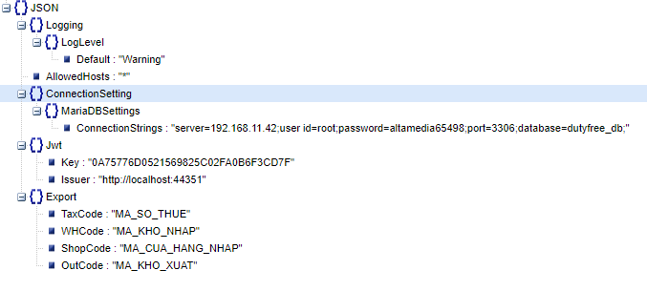

Figure 1: Data structure in file "appsettings.json"

* ***Items do not need to change when changing domain names:***
  + ***ConnectionSetting: MariaDBSettings: ConnectionStrings***: Connection string of MariaDB or MySQL database.
  + ***Jwt: Key***: Secret key token.
  + ***Jwt:* *Issuer****:* Issuer create token.
  + ***Export: TaxCode****:* Corporate tax code used to export reports
  + ***Export: WHCode****:* Warehouse code imported is used to export reports
  + **Export: ShopCode**: The shop code imported is used to export reports
  + **Export: OutCode**: Warehouse code export is used to export reports

# Run and Kill The Dotnet Service

Navigate to the directory containing the source code, then open the terminal:

* ***Run***: dotnet Project.dll.
* ***Kill***: pkill dotnet.
* ***Additional note***: The service will use the default port of 9000.

# Introduction to API Testing Suite

* ***Tools to make***: Postman software
* ***Details of the steps***:
  + Download the API test suite at: DUTY FREE WAREHOUSE.postman_collection.json (Follow the path in Git: \Deployment\Data\API\ DUTY FREE WAREHOUSE.postman_collection.json)
  + Use the import feature of Postman software to import the downloaded API testing suite.
  + Add environment in environment management section with “url” variable representing endpoint API. Ex: http://localhost:9000 or the like
  + Select the newly created environment.
  + Test the operation of the system and data through APIs grouped by modules.

# Trobleshooting

Please, install with administrator privileges.

The End./